UPSKILL CAMPUS (USC) & UCT INTERNSHIP
Industrial Internship Report on
"Smart City Traffic Forecaster & FarmEye – AI Crop & Weed Detector"
Prepared by
Kadingela Ramya
B.Tech – CSE (AI & ML)
Siddhartha Institute of Technology and Sciences
UCT Internship – 2026
GitHub: github.com/Kadingela-Ramya
LinkedIn: linkedin.com/in/ramya-kadingela-21606139b

Table of Contents

Executive Summary 3
Preface 4
Introduction 5
About UniConverge Technologies Pvt Ltd (UCT) 5
About Upskill Campus (USC) 5
Objectives of This Internship 5
Glossary 5
Problem Statement 6
Project 1: FarmEye – Crop & Weed Detection 6
Project 2: Smart City Traffic Forecaster 6
Existing and Proposed Solutions 7
Existing Solutions and Limitations 7
Proposed Solutions 7
Code Submission (GitHub Links) 7
Report Submission (GitHub Link) 7
Proposed Design / Model 8
Project 1: FarmEye – System Design 8
Project 2: Smart City Traffic Forecaster – System Design 10
Performance Test 12
Project 1: FarmEye – Test Cases 12
Project 2: Traffic Forecaster – Performance Outcome 12
My Learnings 13
Future Work Scope 14
FarmEye 14
Smart City Traffic Forecaster 14
General 14
References 14

Executive Summary
This report covers the Industrial Internship provided by Upskill Campus (USC) and UniConverge Technologies Pvt Ltd (UCT). Over 6 weeks, I completed two AI/ML projects: (1) Smart City Traffic Forecaster — a Flask web application using a trained LSTM neural network to predict hourly vehicle counts at city junctions up to 12 hours ahead; and (2) FarmEye — a computer vision application powered by YOLOv8 that detects crops and weeds in farm field images and provides a field health assessment. Both projects are deployed on GitHub, built end-to-end with real datasets, and demonstrate how machine learning can solve practical problems in smart city management and precision agriculture.

Preface
This report documents 6 weeks of industrial internship work with Upskill Campus (USC) and UniConverge Technologies Pvt Ltd (UCT) in 2026. I designed and built two complete AI/ML projects from scratch — each addressing a real-world problem, trained on real datasets, and delivered as a functional web application.
The internship bridged the gap between academic learning and industrial application. Rather than toy problems, I was expected to understand a domain, choose a dataset, train a model, handle deployment challenges, and build a user interface — all independently.
Project 1 — FarmEye — applies YOLOv8 object detection to agricultural field images. Project 2 — Smart City Traffic Forecaster — trains an LSTM on 20 months of junction traffic data to predict the next 12 hours of vehicle counts.
I sincerely thank the Upskill Campus team for organizing this program, and UCT for providing the industry context. This experience pushed me beyond notebooks into real deployment constraints — library conflicts, model serialization, environment differences.
To peers and juniors: commit fully. The problems are real, the deadlines firm, and learning is proportional to effort.

Introduction

About UniConverge Technologies Pvt Ltd (UCT)
UCT is a digital transformation company established in 2013, providing industrial solutions with focus on sustainability and ROI. It works across IoT, Cyber Security, Cloud Computing (AWS, Azure), Machine Learning, Communication Technologies, Java Full Stack, and Python.
- UCT Insight — IoT platform (Java/ReactJS) for dashboard, analytics, alerting, and third-party integration.
- Factory Watch — Smart factory platform for OEE monitoring, predictive maintenance, and digital twin capabilities.
- LoRaWAN Solutions — Agritech, Smart Cities, and metering applications.
- Predictive Maintenance — Industrial machine health monitoring using Embedded Systems, IoT, and ML.

About Upskill Campus (USC)
Upskill Campus is a career development platform delivering personalized executive coaching in an affordable, scalable way. In collaboration with UCT and The IoT Academy, USC facilitates end-to-end internship execution. Website: https://www.upskillcampus.com/

Objectives of This Internship
- Gain practical experience applying AI/ML to real industrial problems.
- Design and implement end-to-end solutions — from data to deployed application.
- Improve job prospects through demonstrable, GitHub-hosted project work.
- Develop problem-solving, technical writing, and independent learning skills.

Glossary
Term | Acronym / Definition
Long Short-Term Memory | LSTM — recurrent neural network suited to time-series forecasting
You Only Look Once (v8) | YOLOv8 — real-time object detection model by Ultralytics
Mean Absolute Error | MAE — average absolute difference between predictions and actual values
Flask | Lightweight Python web framework for serving ML model predictions
Streamlit | Python-based framework for building interactive data apps quickly

Problem Statement

Project 1: FarmEye – Crop & Weed Detection
Farmers spray herbicides uniformly across fields without knowing the actual distribution of weeds. This wastes chemicals, increases costs, and causes environmental harm. A low-cost, image-based tool that identifies weed locations would enable precision spraying and reduce overall herbicide usage.

Project 2: Smart City Traffic Forecaster
Urban traffic management is largely reactive — signals adjust only after congestion builds up. Cities need predictive tools that anticipate traffic peaks at specific junctions hours in advance, so signal timings can be pre-optimized. The challenge: accurately forecast hourly vehicle counts at multiple junctions using historical data.

Existing and Proposed Solutions

Existing Solutions and Limitations
Traffic systems rely on fixed-cycle signals or sensor-triggered reactive systems — they cannot anticipate demand spikes. Weed management relies on manual scouting or blanket spraying — expensive and imprecise. Existing ML solutions are often proprietary, expensive, and inaccessible to city planners or small farmers.

Proposed Solutions
- FarmEye: YOLOv8 trained on the Roboflow CropAndWeed dataset (~2000 annotated images). Identifies crop vs. weed bounding boxes and computes weed density % for field health assessment.
- Smart City Traffic Forecaster: Two-layer LSTM trained on 48,120 hourly records from 4 junctions (Kaggle Traffic Flow dataset). Predicts next 12 hours of vehicle counts at any selected junction.

Code Submission (GitHub Links)
Project 1 – FarmEye:
https://github.com/Kadingela-Ramya/FarmEye-AI

Project 2 – Smart City Traffic Forecaster:
https://github.com/Kadingela-Ramya/Smart_City_Traffic_Forecaster

Report Submission (GitHub Link)
Update the link below once report is pushed to Github
This is my github repository link of both the projects
https://github.com/Kadingela-Ramya/uct-internship-report

Proposed Design / Model

Project 1: FarmEye – System Design
High-Level Flow:
- A field image, or a folder of images, is passed to analyze_field.py, which runs the trained YOLOv8 model (best.pt) on it
- The model detects crop and weed bounding boxes and counts detections per class
- Boxes are drawn back onto the image with a summary banner ('crop' in green, 'weed' in orange)
- Weed coverage (%) estimated as: (sum of weed box areas) ÷ image area × 100 — a bounding-box estimate rather than true pixel-level segmentation, so overlapping weed boxes can occasionally push the figure above 100%
- The annotated image is saved to farmeye_results/, and a per-image text report is written across every image processed
- No interface/UI is built yet — results are viewed directly as annotated images and the text report

Component | Detail
Base Model | YOLOv8n (nano variant, fastest inference)
Training Platform | Google Colab (free T4 GPU)
Dataset | CropAndWeed from Roboflow (~2,000 annotated images)
Training Duration | ~20–30 minutes on T4 GPU
Training Settings | 512×512 images, batch size 16, up to 100 epochs with early stopping after 20 epochs of no improvement
Output | Bounding boxes labelled: crop / weed
Model File | best.pt (placed in models/ folder)

Figure 1: FarmEye – Example 1, Crop with No Weed (agri_0_6504.jpeg)
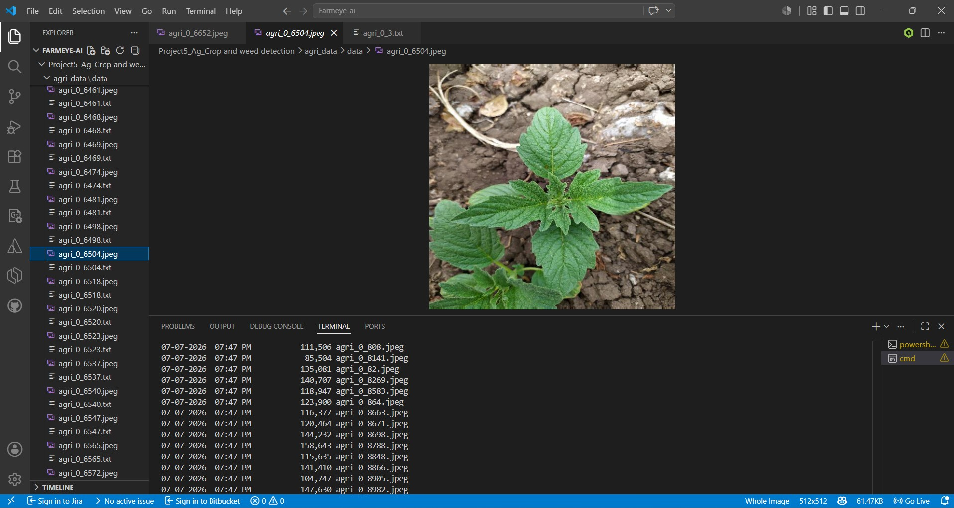  Raw image | 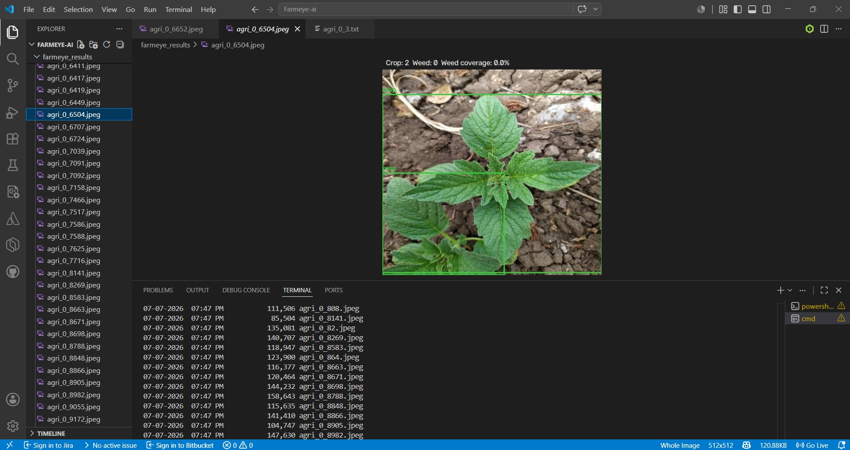  Detected — Crop: 2 Weed: 0 Weed coverage: 0.0%
Two crop plants correctly identified, no weeds present in this frame
Figure 2: FarmEye – Example 2, Mostly Weed (agri_0_6411.jpeg)
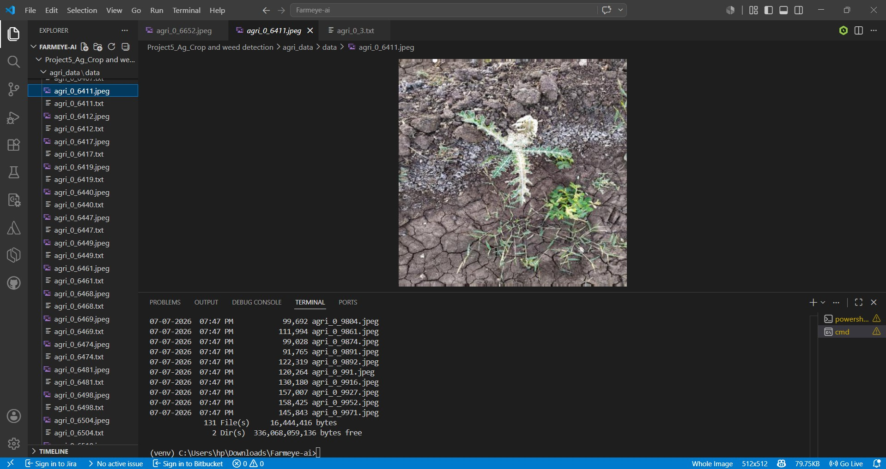  Raw image | 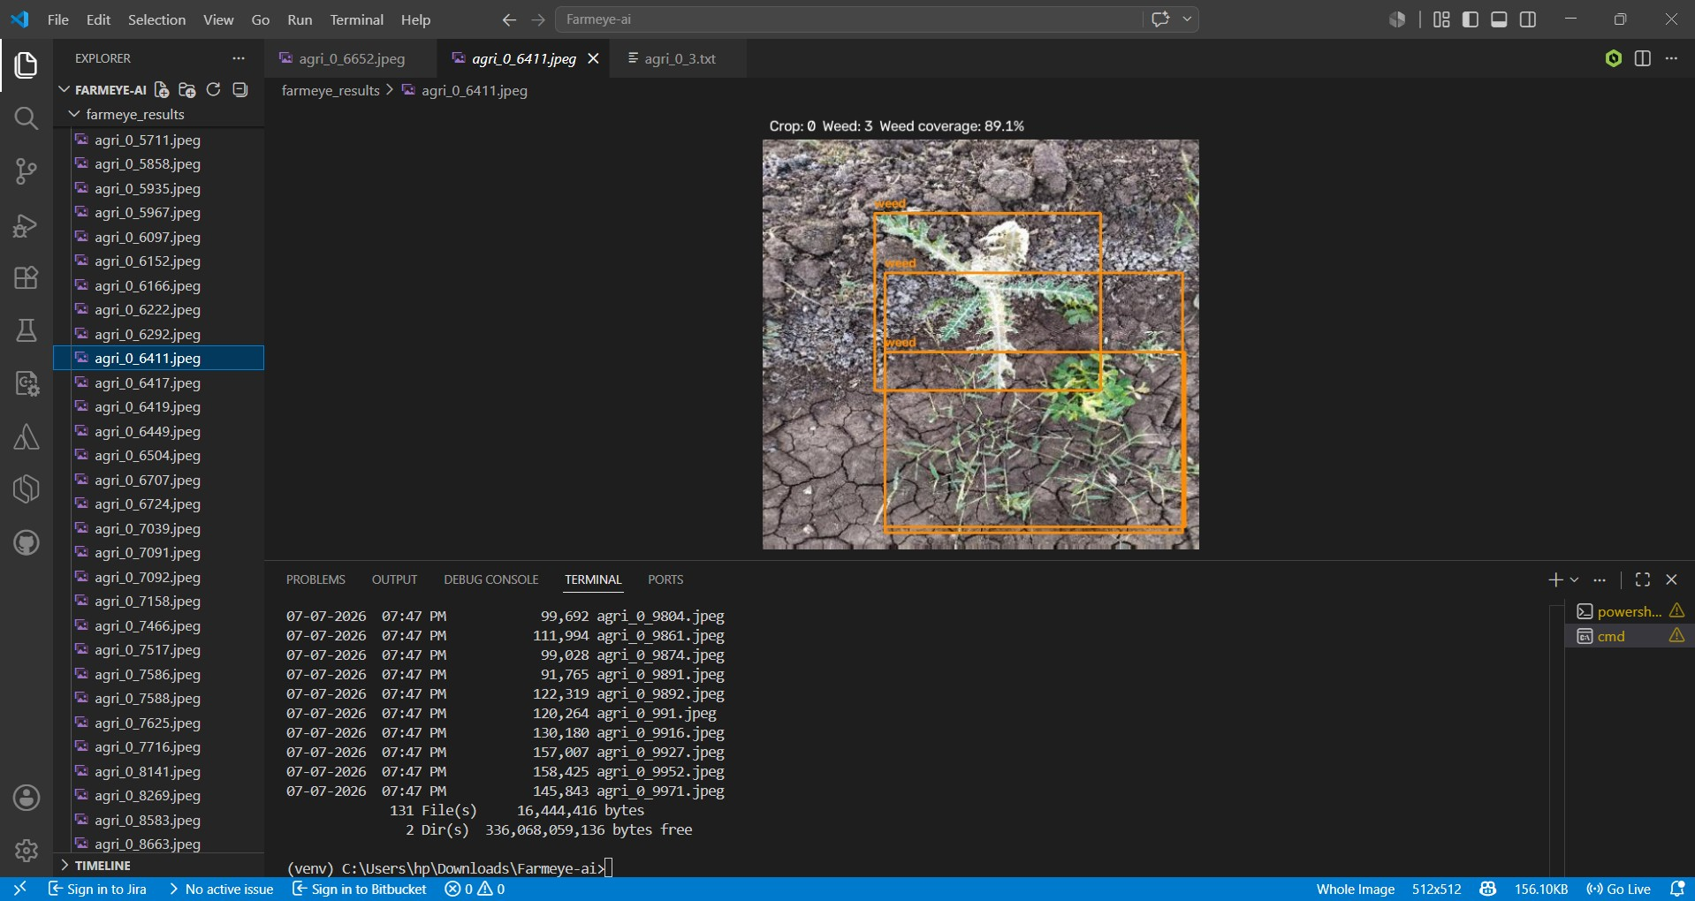  Detected — Crop: 0 Weed: 3 Weed coverage: 89.1%
Three overlapping weed detections; box-area overlap is why coverage figures can occasionally exceed 100% on denser clusters
Results from the last run
- 131 test images processed
- 219 crop detections, 118 weed detections
- 27.2% average weed coverage across all images
Known gaps
- No saved mAP/precision/recall from training — only inference-time detection counts and coverage estimates above
- Weed coverage is a bounding-box area estimate, not true segmentation
- No interface/UI built yet — results are viewed as annotated images and the text report

Project 2: Smart City Traffic Forecaster – System Design
High-Level Flow:
- User selects a junction (J1–J4) and forecast start time via the Flask web interface
- App loads pre-trained LSTM weights (lstm_weights.weights.h5) and scalers from disk
- Input features: hour, day of week, weekend flag, week of year, lag values
- Features scaled using scaler_X.pkl; LSTM predicts next 12 hourly vehicle counts
- Predictions inverse-transformed via scaler_y.pkl and shown as chart + hourly cards

LSTM Architecture:
Layer | Configuration
LSTM Layer 1 | 64 units, return sequences = True
Dropout 1 | 20% dropout
LSTM Layer 2 | 32 units
Dropout 2 | 20% dropout
Dense Layer | 16 units, ReLU activation
Output Layer | 1 unit, linear activation (vehicle count)

Dataset Attribute | Value
Source | Kaggle — Traffic Flow Forecasting dataset
Period Covered | November 2015 – June 2017 (~20 months)
Total Records | 48,120 hourly entries
Junctions | 4 anonymous city junctions
Junction 1 (Central Corridor) | Avg 45 vehicles/hour — High Traffic
Junction 4 (Outer Ring Road) | Avg 7 vehicles/hour — Low Traffic

Figure 3: Smart City Traffic Forecaster – All 4 Junctions
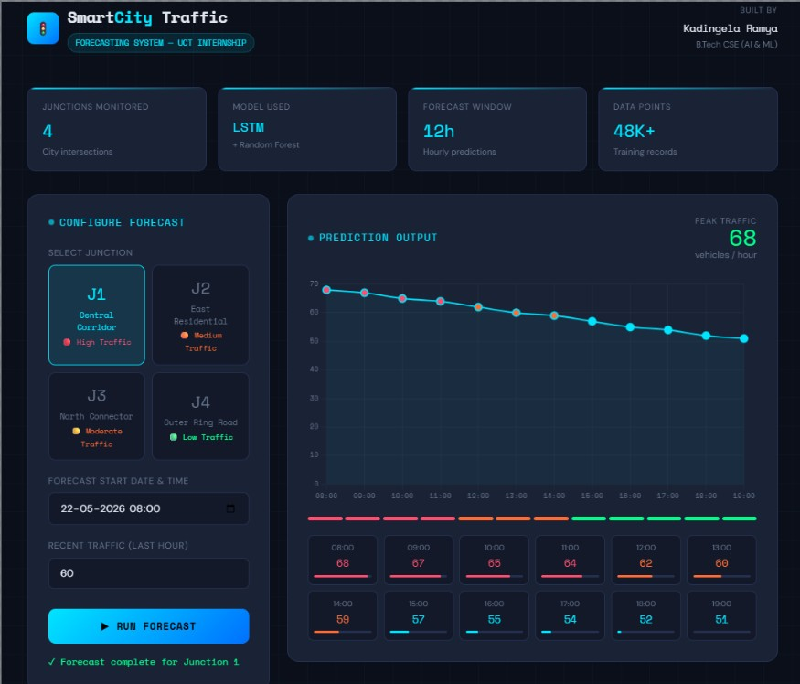  J1 – Central Corridor (Peak: 68 veh/hr) | 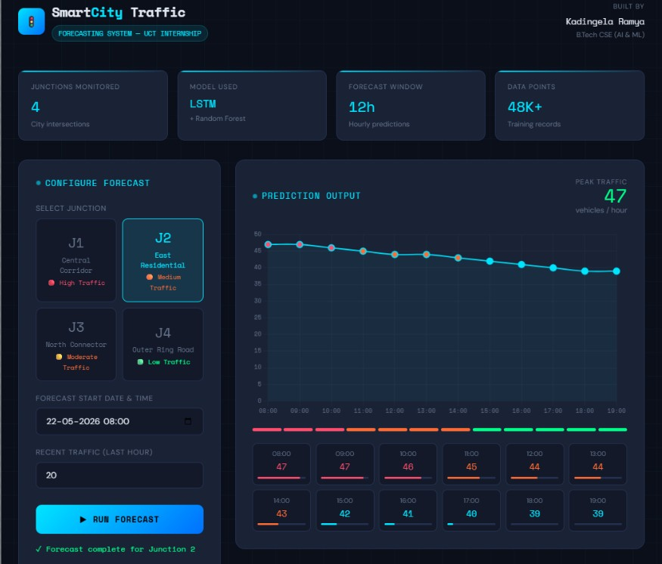  J2 – East Residential (Peak: 47 veh/hr)
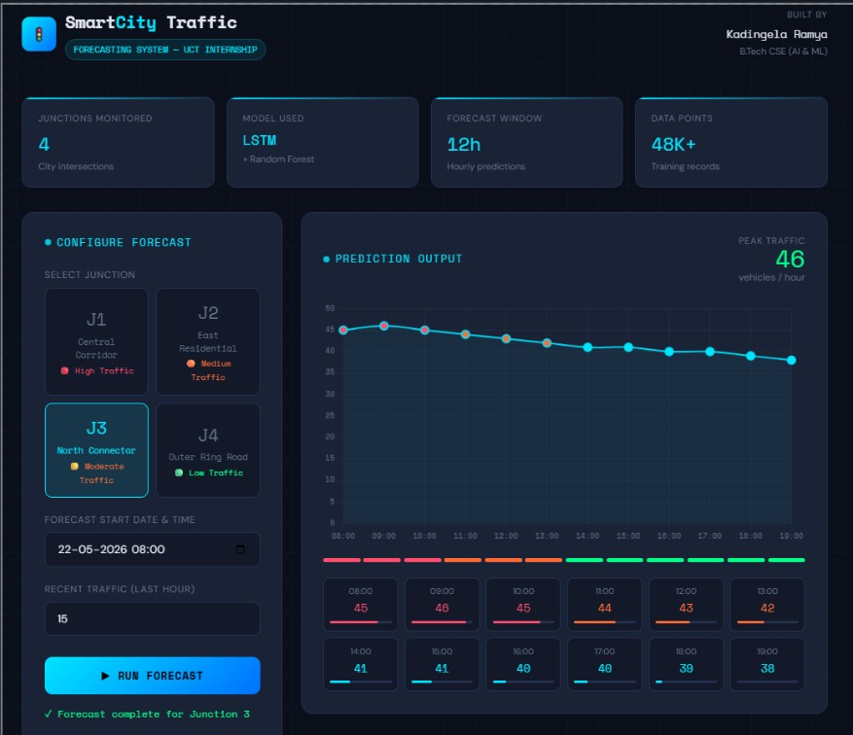  J3 – North Connector (Peak: 46 veh/hr) | 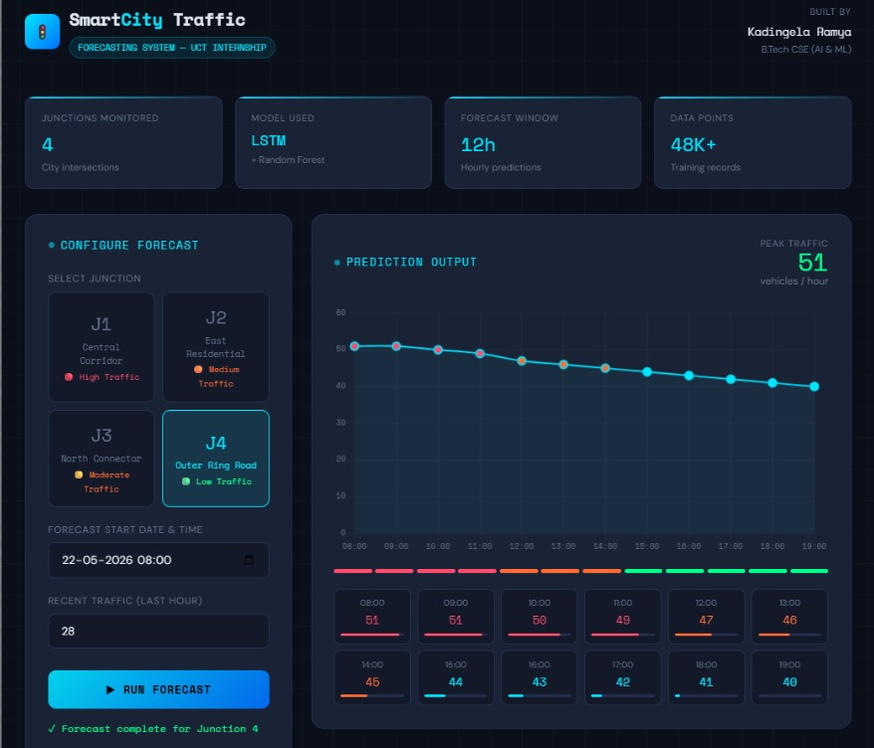  J4 – Outer Ring Road (Peak: 51 veh/hr)

Performance Test

Project 1: FarmEye – Test Cases
Test Case | Input | Expected | Observed
Dense canopy field | High-res crops + weeds | Multiple labelled boxes | Good — individual plant boxes
Bare-soil seedlings | Seedling-stage photo | Detect small plants | Reduced accuracy on small objects
Wide aerial shot | Far-distance crop rows | Row-level detection | Sometimes 1 large box (known limitation)
Empty field | Bare soil image | No detections | Correctly returns 0 detections

Project 2: Traffic Forecaster – Performance Outcome
Metric | Value
Train/Test Split | 80% training, 20% test
Mean Absolute Error (MAE) | ~3.24 vehicles/hour
Practical interpretation | Predictions within 3–4 vehicles of actual count
Relative error (J1 avg 45 veh/hr) | ~7% — acceptable for a planning tool
FarmEye inference time | 158 ms per image at confidence ≥ 0.3

The LSTM achieved MAE of ~3.24 vehicles/hour. FarmEye runs inference in 158 ms per image, fast enough for practical field use. Both models perform reliably on their primary use cases, with known limitations documented in the READMEs.

My Learnings
This internship changed how I think about machine learning. Before it, I thought of ML as model training — fitting curves to data. After it, I understand that training is only about 40% of the real work.
Technical Learnings:
- Model serialization & portability: Keras version conflict between Google Colab and local machine forced me to save only weights (.weights.h5) and rebuild the architecture from code — a critical real-world deployment skill.
- Dependency management: Managing numpy<2 alongside TensorFlow, Flask, joblib, and scikit-learn taught me that requirements.txt is not a formality — version conflicts silently break inference.
- Data engineering for time series: Building LSTM input features (lag values, cyclical time encodings) required structuring sequential data into supervised learning windows.
- YOLOv8 training pipeline: Using Roboflow for dataset management, annotation, and YOLO-format export was a new end-to-end workflow learned from scratch.
- Web deployment: Wrapping ML models in Flask and Streamlit interfaces showed how much work goes into making a model accessible to non-technical users.

Soft Skills:
- Working independently with fixed deadlines forced me to prioritize ruthlessly and ship rather than perfect.
- Writing READMEs that a stranger can follow improved my technical communication significantly.
- Understanding that an honest limitations section makes a project more credible, not less.

Future Work Scope

FarmEye
- Retrain on a larger, more diverse dataset with tighter annotations — especially seedling-stage and varying-altitude images.
- Upgrade from YOLOv8n to YOLOv8s or YOLOv8m for improved accuracy on complex scenes.
- Add GPS metadata support — overlay detections on a field map so farmers see weed hotspots geographically.
- Integrate spray recommendation: compute minimum coverage area needing herbicide treatment.

Smart City Traffic Forecaster
- Expand to multi-junction joint forecasting using a graph neural network — congestion at one junction affects neighbors.
- Incorporate external signals: weather data, events calendar, and school/holiday schedules as features.
- Build a live city dashboard with a map view showing predicted congestion color-coded by junction.
- Explore Transformer-based models (e.g., Temporal Fusion Transformer) as an alternative to LSTM.

General
- Package both apps as Docker containers for reproducible deployment across any machine.
- Write automated test suites for prediction pipelines to catch regressions when model files are updated.

References
[1] Kaggle – Traffic Flow Forecasting Dataset: https://www.kaggle.com/datasets
[2] Roboflow CropAndWeed Dataset: https://roboflow.com/
[3] Ultralytics YOLOv8 Documentation: https://docs.ultralytics.com/
[4] TensorFlow/Keras LSTM Docs: https://www.tensorflow.org/api_docs/python/tf/keras/layers/LSTM
[5] Flask Documentation: https://flask.palletsprojects.com/
[6] Streamlit Documentation: https://docs.streamlit.io/

